2005 Baseball Pool

Modifications to teams
IronHogs +85
River Rats +119
Red Sox 0
RedSox Suck +73
2005 Winner -49
Spidey Senses +50
mikeygee +116
Hamilton Mud Puppies +97

Week 1
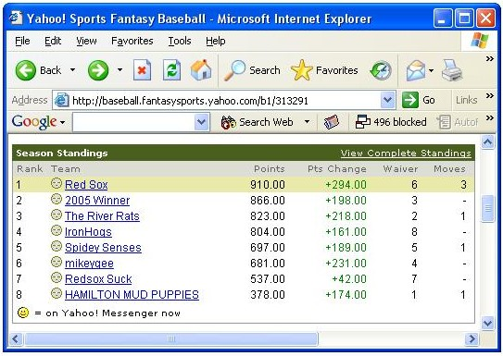
Week 2
Week 3
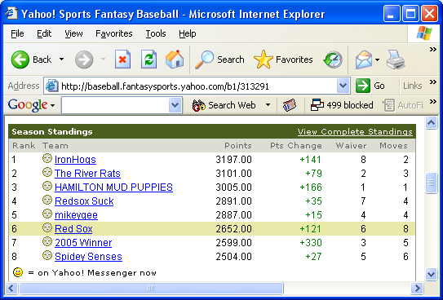

Week 4
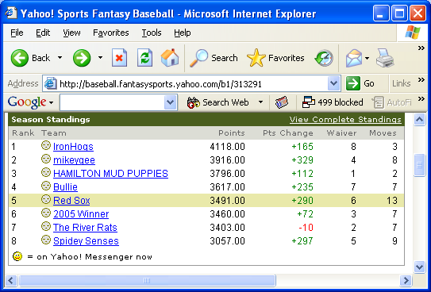

Week 6
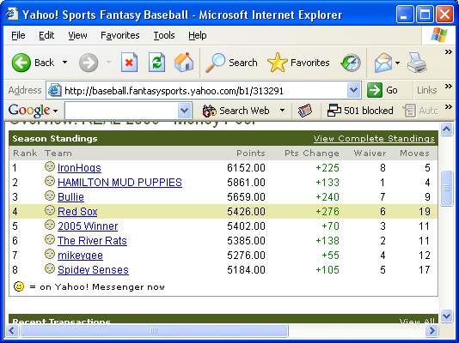

Week 7
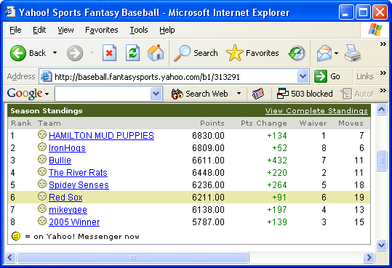

Week 8
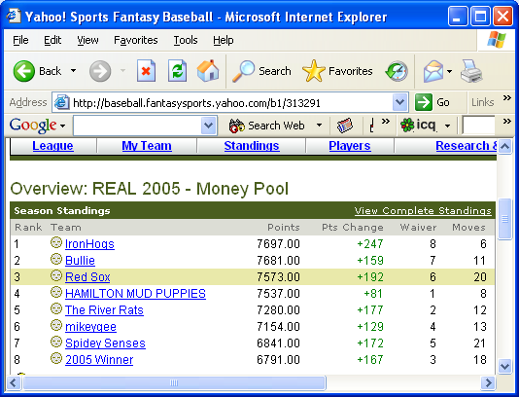

Week 10
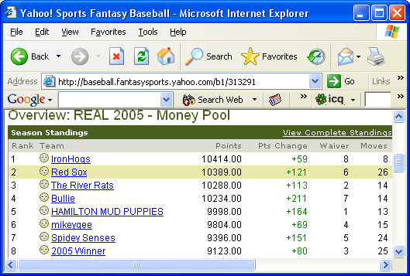

Week 11
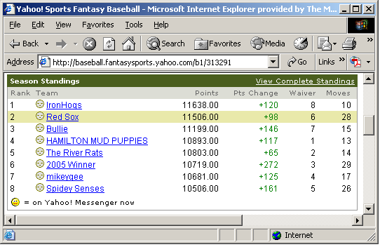
Week 12
